**Build native IOS like hybrid app with AngularJS, PhoneGap and**

**RESTful API( Nodejs, ExpressJs and Mongodb)**

1. **Show the current time of different city user selected which are stored in RESTful API. Also show the difference time in other city with the local time.**

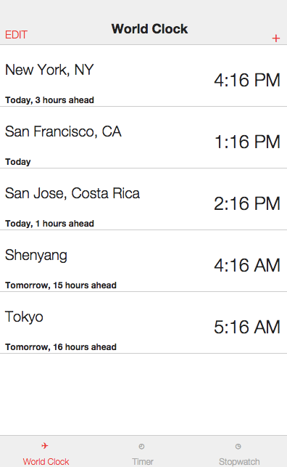

**2. User can delete the selected city.**

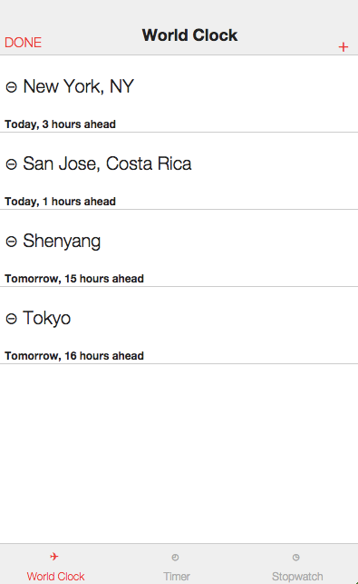

**3. User Can search and add city that calls the RESTful API to persist new city into MongoDB.**

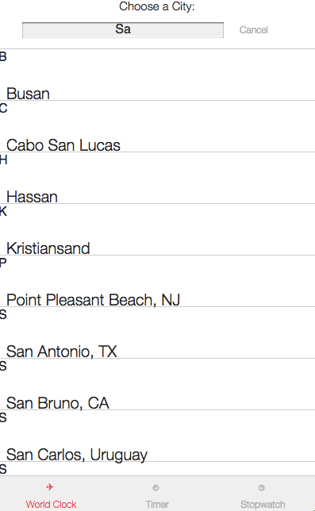

**4. User can set and start the timer and also can pause and cancel the timer.**

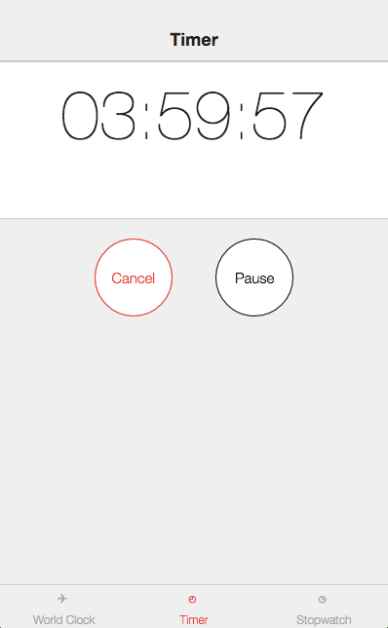

**5. User can start the stop and reset the Stop Watch and add Lap.**

